How does financial condition influences adolescents relationships with peers and parents?

Tianjian Sun, Yunqing Sun

Abstract

This paper set out to evaluate the correlation between adolescents’ household income and their relationship with their parents and peers. In order to do this, we collected quantitative and qualitative data from adolescents in Columbia campus and parks by giving out surveys and interviewing people. We used the following types of analysis in this study: quantitative data analysis and qualitative data analysis. We believe this study is important because we noticed other scholars barely study this topic in the field of adolescents. Our findings might lay a basic foundation for those who are interested in this filed in the future.

Key Terms: financial condition, peer, parents

Background

Adolescents mostly interact with their parents and peers on a daily basis. We tried to find the determinant of adolescents relationships with their parents and their peers.
In the previous researches on adolescents, the once prevailing view of the family at adolescence was one that emphasized the nature and function of parent–adolescent conflicts (for a review, see Steinberg, 1990). Especially those written by neoanalytic theorists, such as Erikson’s portrayal of the adolescent “identity crisis” (1968) and Blos’s notions about “individuation” (1967). These theories were disproved by empirical studies that found approximately 75% of teenagers re- ported having happy and pleasant relationships with their parents (e.g., Douvan & Adelson, 1966; Kandel & Lesser, 1972; Offer, 1969). Detachment, identity struggle, and individuation did not seem to be taking their toll on the family.
Based on previous study, it seems adolescents relationships are likely to be influenced by their parents. Adolescents whose parents encourage their psychological autonomy, for example, are relatively more competent than other youngsters in their interactions with peers (Allen, Boykin, & Bell, 2000). Adolescents and their friends share various inclinations and attitudes in common because adolescents choose people who are similar to themselves as their friends(Cairns, Cairns, Neckerman, Gest, & Gariepy, 1988; Epstein, 1983; Hogue & Steinberg, 1995; Kandel, 1978).
According to prior research, since cultural differences in parenting patterns and peer groups are existing, we targeted at adolescents in New York City. The assumption of our research is adolescents’ financial condition has an impact on how they deal with the relationships between their parents and peers, for we believe parents from a higher economic status would invest more on their children.

Design

The independent variable of our design is the adolescent financial background, and the dependent variable stands for the relationship between adolescents with their peers and their parents. Financial background is the amount of money a family have and at the same time, the maximize money spent on their children. This has a huge impact on adolescents well-rounded development, and might be a valuable source in the conduction of our survey. Also, adolescents are at a particular age of having the need of accompanying as well as the sense of identity, while parents and peers are the two major sources that have enormous contributions on helping adolescents overcoming this stage. But since there are only 24 hours a day to spend, there must be a choice on deciding who to spend more time with and who to trust more. There are many factors that may correlate closely to the selection, but this search is interested in what role can financial background play in the decision. In our design, we assume that while with higher financial background, adolescents are expected to have a closer relationship with their family, but at the same time, their relationship with their peers may be weaker in comparison to those with the poor financial background.

Sample
This research faces all the adolescents aged from 12-18 in the NYC. But since we will never have time to check all the adolescents in this city, we are trying to find adolescents that can be a good representative of the whole. And since adolescent’s unique financial background serve as the independent variable for this study, we are looking forward to surveying adolescents from all ranges of social classes. For example, the students at the other summer program at Columbia university don’t often be disturbed by financial problems, but that might not work for adolescents taking a part-time job at the fast food restaurant. So in order to have the diversity in the sample, our initial though are places like churches, parks, universities, high schools, soccer court which have a large probability of encountering all kinds of adolescents to meet our purpose.

Method
We plan to use quantitative method in the form of method combining with several open-ended interviews. For the questionnaire part, in order to measure adolescents’ financial background and their relationship with their peers and family under different financial background, we plan to design several sub-variables to replace the original ones to have a broader sense. For example, the ranking of satisfaction towards their family’s financial situation, their family’s household income, and adolescent’s monthly allowances are taken into account to measure the adolescent’s financial background. On the other hand, the hours of time spending with their parents and peers, the common topic shared with their parents, the attitude towards their parents are some good indicators of the difference between the two kind of relationship. These are some of the representatives we found that can answer our questions more directly, and might be easier for adolescents to answer taking into considerations of their education level and social experience. Also, we set several sub-variables instead of one for each variables to make sure we can actually obtain something useful if adolescents are not willing to share some personal information. (I.e. the ranking of satisfaction can be a backup plan if adolescents refuse to talk about their family’s household income). The questionnaire we designed consists of both multiple choices and single responses questions to make sure the information obtained is precise. And beside the “useful” questions that correlate closely to our survey, we have also set some questions that seems to be “meaningless”(age, gender, religious). This act was not only to comfort the person completing the survey, but also to record information that might be helpful for further research. It will probably take 2 minutes of their time to finish, while during this time we might take photos of them doing the survey after having their permissions. When the questionnaires are filled out, we will analyze the useful data as it is listed above, by basically putting the answer into different categories and use scatter plot diagram to find whether there exists a positive or negative relationship between the two variables. (i.e. The x coordinate could be their family’s financial situation with the y coordinate being the time adolescents spent with their parents, well the results on the scatter plot diagram with a regression line can be a good way to clarify the trend ). Pie chart will also be needed in order to show the distribution of certain answers(i.e when we are counting and analyzing the portion of adolescents who trust their parents more than their peers, pie chart may serve as a good tool to show a very clear and direct comparison to the adolescents who trust their friends more).

And for some adolescents who is both time available and feel fine to have their voice recorded, we will have a 10-minute interview with them. The interview will start from simple open minded and easy questions to comfort the interviewee to feel less stressful, but the degree of difficulties will be rising as time goes on. The questions will still be about the relationship with their parents and peers, but are expected to receive more precise results with their feelings recorded and taken into account(based on their facial expression and the tone of speaking). The interview mainly served as a back-up plan(in case no one is willing to try), but if there are certain volunteers, the results will be considered to be a more reliable and a more accurate source of information. After the interview, we will write down some of the main points obtained from the notes taken and the video recorded. These information will be used to compare with the data from the questionnaire, thus confirming the accuracy of the presenting of the final results, to make sure everything is on the right track.

The final result will be presenting after all these steps are finished.

Execution
From all the information we obtained form the questionnaires(38), we tried to find a reliable relationship that could explain our hypothesis. After drawing some rough drafts to simulate certain relationships. We decided to use family’s household income as the independent variable and let the ranking of relationship be the dependent variable. After the decision, we type the data in the computer to design a scatter plot to see whether the diagram reveals our hypothesis. These diagram above reveals the relationship adolescents have with their parents or their peers under different financial background, with the horizontal coordinate act as measurement of household income and vertical coordinate serve as the ranking of relationship. The household income is counted yearly and it has 4 level. With 1 stands for under $20,000 per year, 2 stands for $20,000-53,000, 3 stands for $53,000-86,000, and 4 stand for more than $86,000. The ranking of relationship has 5 levels, ranging from the lowest(1) to the highest(5). And in order to show a clearer relationship, we calculate the mean of ranking under each level of financial background. So event though the some of the data looks the same in the box,(because of the binary system used in designing), there is actually great difference between these data.
And here are the data we have analyzed.
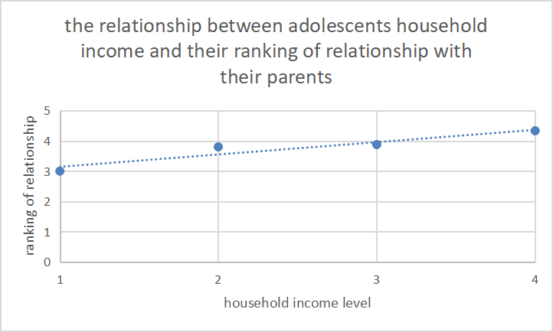
From observing this diagram above, it is not hard to find a positive correlation between adolescents family’s household income and the ranking of their relationship with their parents. Even enough the trend is not strong, it is still can support our hypothesis. But since the relationship is not as strong as we thought it to be, we believe there are some hiding factors we have fail to investigate on.(i.e religion)
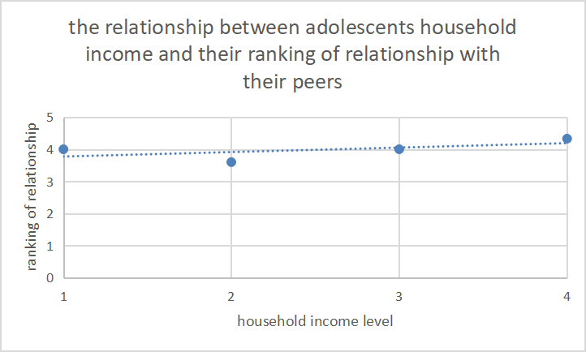
This diagram above shows a weak correlation between adolescents’ household income and the relationship ranking with peers. This finding does not match our original thought because we though there might be a downward relationship, it is either because the sample size we is not big enough to prove the theory, or is because there are some other related factors which may contribute to the slope that we have failed to take into account.(i.e. gender)

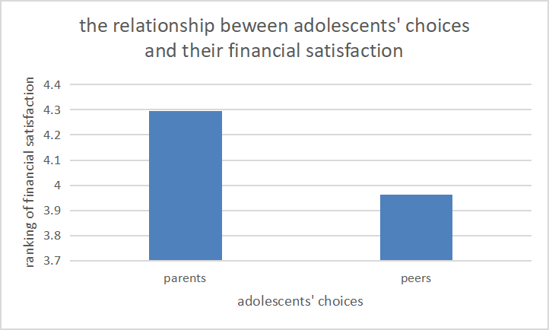
The question related to this diagram above is that when adolescent have to choose either their parent or their friend to share a secret, who would be their choice. The vertical coordinate serve as the mean ranking of satisfaction towards their household income under different choices, while the horizontal coordinate represent their choices of who to share a secret. This bar graph shows explicitly that adolescents who choose parents to be the first one to ask for help generally has a higher financial satisfaction in their household income. This proves our hypothesis that adolescents with higher financial background tend to develop closer relationship with their parents, and will somehow weaker their relationship with their peers.

Limitation and future direction

In the survey, we designed other social background questions besides household income. However, we didn’t take them into account. Since time is the biggest hindrance to our research, we couldn’t analysis how the adolescents’ religion background influence their attitudes toward parents or how the parents’ different origin culture determines their parenting style. We also neglected the gender differences while doing the research. According to psychologists, girls and boys have different estrogen and testosterone level during puberty, which causes them to act differently in daily life. Another limitation is that we didn’t go to other blocks in New York City, so our sample might not be diverse enough.
Future studies should include these important social background elements that somehow affect adolescents’ relationships with their parents and peers. Follow-up studies should apply more research methods. For instance, employ the natural observation approach to obtain a more authentic knowledge of how adolescents interact with their parents and peers. Because they might not be completely honest in self-reported surveys.

Reference

Justin Jager, Cynthia X. Yuen, Diane L. Putnick, Charlene Hendricks, and Marc H. Bornstein. 2015 “Adolescent-Peer Relationships, Separation and Detachment From Parents, and Internalizing and Externalizing Behaviors: Linkages and Interactions?” Journal of Early Adolescence (https://doi.org/10.1177/0272431614537116)

Inge Seiffge-Krenke and Malte Persike,Neslihan Gu ̈ney Karaman,Dora Herrera, Petr Macek, Figen Cok ,Iffat Rohail. 2013“Stress With Parents and Peers: How Adolescents From Six Nations Cope With Relationship Stress” Journal of Research on Adolescence (https://eric.ed.gov/?id=EJ1009634)
Laurence Steinberg. 2001 “We Know Some Things: Parent–Adolescent Relationships in Retrospect and Prospect” Journal of research on adolescence (https://onlinelibrary.wiley.com/doi/abs/10.1111/1532-7795.00001)

