Interracial Friendships of International Adolescent Students: A Focus on Diversity of Grown-up Environment, Humanity-related Education Received, and Level of Parental Interference

[Abstract]
The purpose of this study is to look at the status of cross-race relationships, specifically friendships, of international adolescent students who have stayed in the United States for a period of time. This paper is set out to evaluate the influences of the diversity of the environment where these students grew up, the level of humanity-related education received, and level of parental intervention on adolescents’ social activities on the quantity and quality of their interracial friendships. In order to do this, we will collect both quantitative and qualitative data from surveys and interviews. We mainly target international students who have stayed in the state for less than 2 years to make sure not only that their original growing environment still largely influences their social interaction but also that they have enough experience interacting with peers of other races. We may start sampling from Chinese and Italian adolescents due to their clear difference in background, and then snowball to more groups. From the survey samples we receive, we will randomly select 2-3 respondents who claim “willing to accept” an interview in order to understand the potential correlation in-depth. We believe this study is important because interracial friendships are inevitable for the trend of globalization, especially for international students like ourselves. There must have been obstacles for those students to make friends with peers of other races. We want to know whether the problem we have confronted with is a pattern or not, and we also want to find out the underlying factors behind it Understanding it thoroughly may help people overcome the problems.

[Background and Significance]
The basic question this paper wants to answer is that of what factor(s) affect the quantity and quality of interracial friendships among international students in the United States.
Interracial Friendships
Friendships are of great importance to the both the physical and psychological development and well being of adolescents. Research on adolescents has consistently demonstrated that friendships with peers are positively associated with self-esteem (Cauce, 1986; Keefe & Berndt 1996; Ryan, Stiller, & Lynch 1994) and negatively associated with depression (Aseltine, Gore, &Colten 1994). In today’s racially and ethnically diverse society, cross-race friendships are particularly critical to the positive development of adolescents. Friendships with other racial group members provide opportunities for personal and meaningful interactions and therefore can help reduce stereotypes and promote more positive racial attitudes (Wing Yi Chan, Dina Birman 2009).
International Students in the United States
In 2008, there were more than 3.3 million tertiary international students worldwide (OECD 2010). Over half of all tertiary international students choose to study in the United States of America (U.S.A.) (19%), the United Kingdom (U.K.) (10%), Germany (7%), France (7%), and Australia (7%) (OECD 2010). International students are an important financial commodity for these countries contributing approximately $19 billion (U.S. dollars) annually to each of the Australian and U.S. economies (NAFSA 2010).
International students are not only a valuable financial asset to universities; they are individuals who also enrich these countries with their diverse heritage and perspectives, thus, serving to increase cultural awareness and appreciation (Bevis, 2002; Harrison, 2002). Moving to a foreign country to study brings many potential challenges, and international students may experience acculturative stress and adjustment problems.
While literature reviews have previously investigated the array of stressors that international students face (e.g., Andrade 2006; Chen 1999; Mori 2000), previous research on friendship international students showed that international students often have more friends from their home country (Schwartz, Unger, Zamboanga, & Szapocznik 2010). But debate also exists, claiming that international students did not report having a higher ratio of individuals from their home country in their friendship networks. However, international students with a higher ratio of individuals from the host country in their network claimed to be more satisfied, content, and less homesick (Blake Hendrickson, Devan Rosen, R. Kelly Aune 2010).
Theoretical Perspective
Because prior literature has suggested that school diversity has a positive impact on cross-race friendships, we hypothesized that:
- Higher levels of school/growing environment’s racial diversity would predict students reporting having more cross-race friendships and better the quality of interracial friendships they have.
- The more humanity-related education students have received the more cross-race friendships and the better the quality of interracial friendships they have.
- The more parents interfere in adolescents’ social life, the less cross-race friendships and the worse the quality of interracial friendships they have.
Younger adolescents often have more same-race friendships (Aboud, Mendelson, &Purdy 2003; DuBois& Hirsch 1990; Shrum, Cheek, & Hunter 1988). In one study, female adolescents reported more reciprocated/mutual cross-race friendships than their male counterparts (Clark & Ayers 1992). However, girls in third grade were found to have fewer cross-race friendships at school than boys regardless of their race (Shrum et al. 1988). Further, gender has been found to be related to acculturation across studies (Birman & Trickett 2001; Birman & Tyler 1994).
Previous research also suggests that length of residency in the U.S. is an important covariate of acculturation and predictor of adaptation to cross-race interaction (Birman & Trickett 2001; Birman & Tyler 1994).
Joyner and Kao (2000) found that students were more likely to have cross-race friendships when they did not have the opportunity to interact with students of their own race and therefore they would be more compelled to interact with students of other racial backgrounds (Joyner & Kao 2000; Quillian & Campbell 2003). The findings of these two studies support the social contact theory: as the opportunities to interact with other racial/ethnic group member increase, the number of cross-race friendships also increases. In both studies, school diversity was determined by the proportion of students who are from the same racial group as the participant (Joyner & Kao, 2000; Quillian & Campbell, 2003). Such a measure of diversity, however, is incomplete because it does not provide information about the number of different racial/ethnic groups and the relative proportions of these groups. These two pieces of information are important because as the number of racial/ethnic groups increases, the dynamic among different groups changes because there may not be a majority group. Also, a school with more equal proportions of different racial/ethnic groups could potentially have a very different, possibly friendlier environment, than a school that has the same number of groups but is disproportionate.
Based on all these arguable explanation about the issue, we want to focus on international students and to examine the effect with improvement in methodology.

[Design]
The dependent variables we considered are the interracial relationships like friendship or love relationships, both determined by our independent variables which are multiples: social background, education received, and parental influence.
A higher level of racial distribution leads to more interracial relationships amongst adolescents. Where immigration is a problem in the politic agenda like in Italy and New York City we have a significantly higher level of interracial relationships.
We decided to analyze this process with three different realities: Chinese, Italian and New York City, asking to adolescents from these parts of the world to answer a survey.
Our online surveys are structured like a questionnaire and are our main source of information. Our team scanned circa 40 surveys from these three “worlds”. The online surveys consider both national and individual problems like prejudices and percentage of friends from different cultures that every interviewee has. We also tried to analyze the inner part of this problem by asking if they have classes at school about this topic. (If they have not, they will skip that part).The online surveys are valid only for the Italian and Chinese students. The New Yorkers will answer those questions orally and maybe one or more of them will have a more complete and deeper interview. (New Yorkers are not just the official inhabitants of NYC but also Summer Camp students, tourists and so on). The results of the New Yorkers will be added to our graphs too.
We used a snowball sample since we decided to ask questions only to students who were at the time of the interview near the Columbia University Library and Riverside Park.
The data will be collected and we’ll make graphs of them to see clearly what happened and compare these situations. The graphs are going to show us what factors affect the interracial relationships.
The research originally mainly assumes that higher diversity of ethnic groups at school, more humanities classes related to races and international relationships and less parental interference of socialization are more likely to lead to higher quantity and quality of interracial friendships. Firstly, according to recent research, structural diversity tends to be positively associated with occurrence of interracial friendships and even interracial affection (Structural Diversity and Close Interracial Relationships in College, Nicholas. B 2012). Besides, we logically assume that high diversity of races in campus can raise the accessibility to interracial relationships, which is constructive for students to develop further friendship. Secondly, at present there is no study which is able to accurately address our questions about correlation between humanity classes and interracial friendship. However, we logically hypothesize that this sort of class can enhance students’ awareness of interracial relationships with which they may seek for friendship due to some positive effects they expect. Thirdly, albeit lack of evidence of previous research supporting our theory, according to our predictions, parental interference on socialization, which may probably involve certain prejudices or stigma towards specific ethnic groups, may exert a further influence in adolescents’ interracial friendships.
Our general technique is observational research, including surveys of teenagers mainly in China, US, and Italy and several in-depth interviews. Our survey mainly involves systematic sampling and snowball sampling. In order to identify influential factors, we tend to do deliberately confine our population to the three main sorts of populations. These populations are in different social and cultural contexts, which enable us to make comparisons among the factors. Snowball sampling is adopted as a vital methodology because teenagers with accessibility to interracial friendships are rare around us. Only international students who have overseas programs or exchange projects can experience such friendship. To deal with this situation, we find certain people as source of population to help us expand our samples. For example, researcher Frank Xu is a grade 10 student most of whose classmates have experiences without interracial friendships. Nevertheless, by communicating with his friends taking summer programs in grade 11, Frank successfully obtained more population with interracial friendships. Therefore, our research may take into account students of summer programs in other universities such as Georgetown, Duke and Yale. In the city of New York, we found a group of students from Argentina and several Chinese students, one of which will be included in the interview. For survey questions, we deliberately involve questions corresponding to each of our factors. Nominal, ordinal and continuous measurement of independent variables are involved. Questions like categories of races are nominal; questions relating to extent (e.g. extent of parental interference) are ordinal; questions where we can easily attain accurate numbers or ranges (e.g. numbers of humanity classes) are continuous. The source of in-depth interview can be attained on the survey as we ask them whether they are willing to complete a 20-minute interview later. Our interview samples can be adolescent pedestrians in the city or someone else online.
To analyze the data, we can utilize the automatic functions of the online interview machine to acquire charts on distributions of options of each question. Correlation model on applications like R can be built to test our predictions of factors. Electronic audio may be used in the interviews and the dialogue will be transiting to appropriate contents shown on our research results.

[Execution]
We finally collected 49 samples, which exceeds our expectation. In the process, apart from three main factors in our design, we add two more factors, how much they like making interracial friends and extend of socialization (measured by the number of friends they meet during a week). At first, we obtained a table with some nominal variables, as the figure 1 shows.
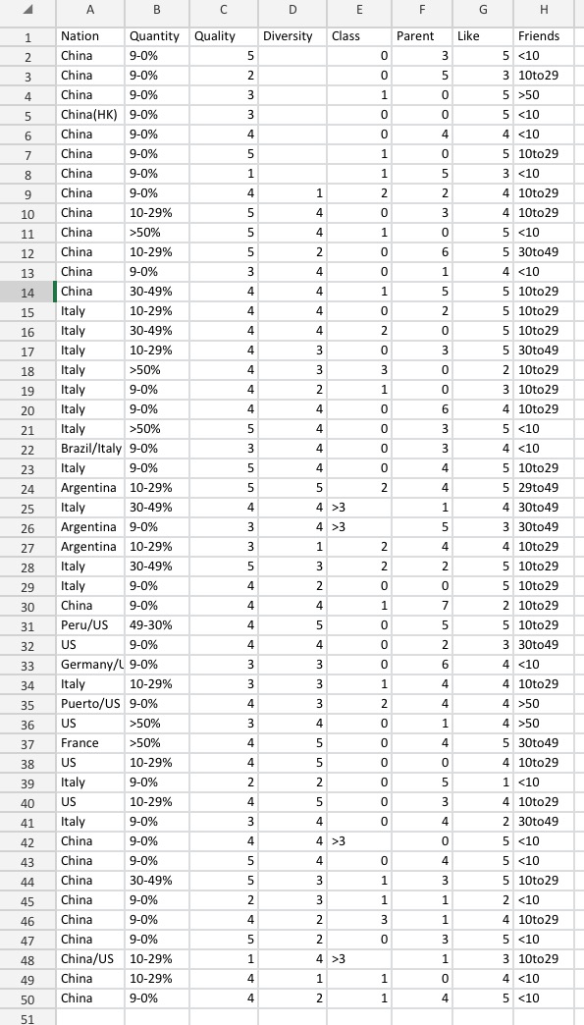 Fig 1.1
However, in order to make a linear regression, we made some adjustments. As figure 2 on the right shows, nominal variables are changed into ordinal variables. In order to build an equivalent scale to measure our variables, all the ordinal digital measurements are in the range of 0-10. To processing the nominal variable of ranges of proportions, we calculated the mean of each range and times with ten. Similarly, the mean of range of numbers of friends are divided by 10. Apart from this, several ranges named by ‘>3’ are changed into 5 as most schools seems not to have humanity class about races and international relationships twice a day. Through such a way, in the process, the distance of original ranges is inherited by ordinal values, which enables our data analysis more accurate.
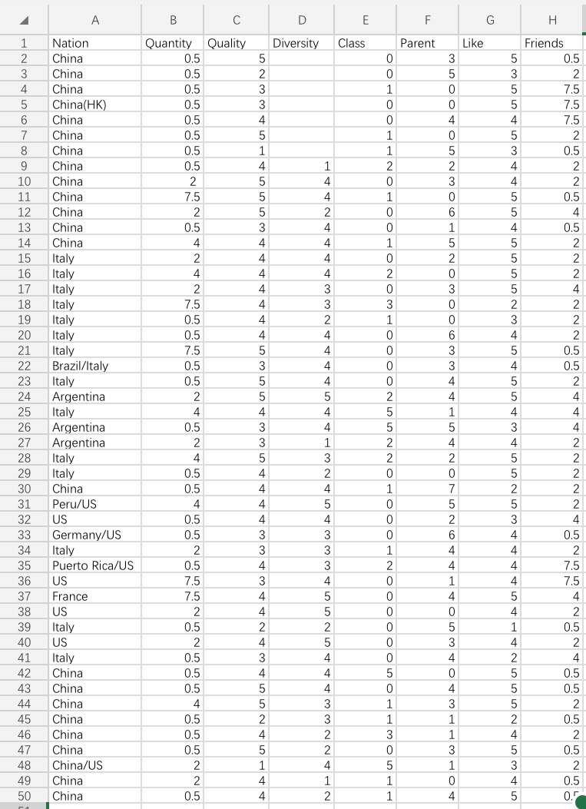 Fig1.2
By analyzing these data in the R-studio, we obtained the multiple linear regressions. Because each variable works in the context where other variables are not controlled to remain the same, we adopt multiple linear regression rather than respective correlation. The dependent variable of two groups respectively are quality (support individuals get) and quantity (proportions) of interracial friends.
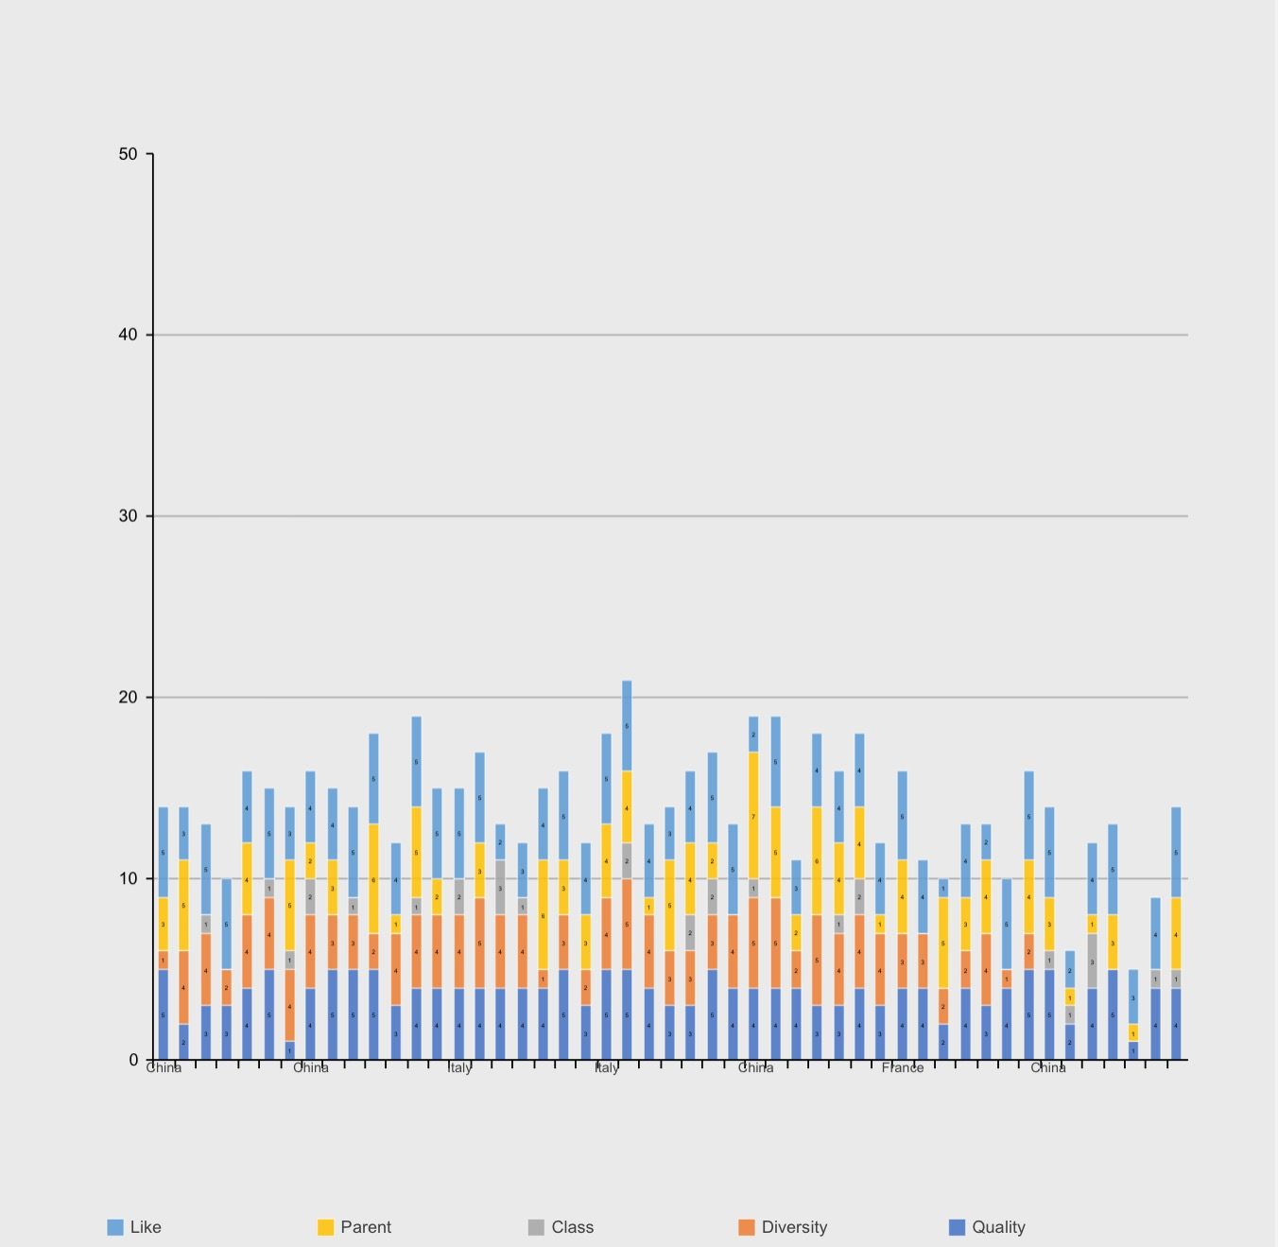Quality
Coefficients:
Estimate Std. Error t value Pr(>|t|)
(Intercept) 1.818259 0.606076 3.000 0.00488 **
Diversity -0.016990 0.106260 -0.160 0.87386
Class -0.086070 0.079862 -1.078 0.28832
Parent 0.007883 0.061156 0.129 0.89816
Like 0.528352 0.110878 4.765 3.07e-05 ***
Friends 0.019661 0.070931 0.277 0.78323
Residual standard error: 0.7431
Quantity
Coefficients:
Estimate Std. Error t value Pr(>|t|)
(Intercept) -0.85623 1.77731 -0.482 0.6329
Diversity 0.52845 0.31161 1.696 0.0985 .
Class -0.06407 0.23419 -0.274 0.7860
Parent -0.31771 0.17934 -1.772 0.0849 .
Like 0.41902 0.32515 1.289 0.2057
Friends 0.24338 0.20801 1.170 0.2497
Residual standard error: 2.179

Unexpectedly, the vital factor to affect the quality of interracial friendship proved to be how much they like making interracial friends. The passion of making interracial friends probably nudged them to seek friends of good quality and support from them when needed. Besides, the rest of the factors tend to exert tiny influence on the quality of interracial relationships. The explanation for this phenomenon might be difference of real situation in different contexts.
In contrast, the quantity group tend more to be in our extend of prediction. The diversity of race at schools proved to be the crucial factor to affect the quantity of interracial friends. Accessibility does motivate adolescents to build friendships with people from other races. On top of that, passion does play a significant role of building interracial relationships in aspects of both quality and quantity. As we expect, the parental interference does negatively affect the quantity of interracial friendships. Rigid controls may lower the accessibility of interracial friends. However, unexpectedly, there tends to be slight connections between humanity class and interracial friendships. A plausible explanation might be that these classes sometimes can subtly spread negative stereotypes of certain races, albeit the expansion of cognition of other races.
The first literature interviewee is a Chinese student. Here is part of the record of our online conversation:
Q: Could you tell me one of interracial friends?
A: Yes. One of my friends is from Kazakhstan. He has white skin. When I was about to leave, he came to me and embraced me…
Q: Could you share your opinion about the difference of interracial and domestic friendships?
A: When I am facing domestic friends, I will feel more comfortable and do not think about the culture gap and vice versa…
According to the literature interview, cultural gap can be one of the factors negatively influence the interracial relationship. The cultural gap may be related to the factors we studied previously, such as numbers of humanity classes and racial diversity.

[Discussion & Conclusion]
Limitations
This part will mainly focus on the limitation and infeasibility of the project. Firstly, due to the time restriction and limited source of potential interviewees, the number sample obtained only remains 50, which is not constructive for us to ensure the generalization problem. Besides, some of them are in clusters as the snowball sampling is more likely to help us attain samples close to the ‘source’ provider. Certain clusters tend to develop specific norms. Consequently, we may just have studied the factors of interracial friendships under a norm instead of a macroscopic context. What's more, since we adjusted the survey questions at the beginning, a little part of data cannot be obtained, conducting errors. Moreover, the data analysis may be somehow inaccurate as the measurements are all ordinal. This can be attributed to the inappropriate design of certain parts of the questionnaire. For instance, the question about numbers of humanity class had better to directly ask the certain number (to be as a QA style rather than MCQ), rather than giving a range in the last option. Meanwhile, we are unable to test the authenticity of the answers.
Secondly, our research only focuses on several factors influencing the quantity and quality of interracial relationships. In fact, there can be enormous sum of the factors. Presumably there are factors which can exert a more profound and apparent influence on the quantity and quality of interracial friendships. When we attempt to manipulate the independent variables we focus on, other potential important factors may change meanwhile. On top of that, we are not able to control other factors to remain equivalent. In order to minimize the errors, we should have had as many samples as possible, which we failed doing so. There are also many obstacles in the execution. The fact that printed questionnaires are not adopted can be one of the problems for our research, which can be attributed to our inappropriate design. Efficiency of our street sampling is lowered as pedestrians have to finish it on our electronic equipments one by one. In contrast, if we send them address of survey, they are always not willing to do instantly and may forget about it later. Besides, due to lack of term explanation, some people may find it hard to identify certain races, creating errors in our survey. Moreover, due to the interviewees are not motivated, the interviews are of low quality, some of them even can't correspond to our questions. As a result, we finally analyzed only one sample.
Conclusions
In conclusion, taking into account the independent variables surveyed and analyzed the passion of making interracial friends play an important role in both quantity and quality of interracial friendship while diversity of races at school, parental influence and socialization works effectively in the aspect of quantity. The parental interference is more likely to have little correlation for both aspects.

[Bibliography]
Aboud, F. E., Mendelson, M. J., & Purdy, K. 2003. “Cross-race peer relations and friendship quality.” International Journal of Behavioral Development 27, 165–173.
Aseltine, R. H., Gore, S., & Colten, M. E. 1994. “Depression and the social developmental context of adolescence.” Journal of Personality and Social Psychology 67, 252– 263.
Bevis, T. B. 2002. “At a glance: International students in the United States.” International Educator 11(3), 12–17.
Birman, D. 1998. “Biculturalism and perceived competence of Latino immigrant adolescents.” American Journal of Community Psychology 26, 335–354.
Birman, D., & Trickett, E. J. 2001. “Cultural transitions in first-generation immigrants: Acculturation of Soviet Jewish refugee adolescents and parents.” Journal of Cross-Cultural Psychology 32, 456–477.
Birman, D., Trickett, E. J., & Vinokurov, A. 2002. “Acculturation and adaptation of Soviet Jewish refugee adolescents: Predictors of adjustment across life domains.” American Journal of Community Psychology 30, 585–607.
Birman, D., & Tyler, F. B. 1994. “Acculturation and alienation of Soviet Jewish refugees in the United States.” Genetic, Social, and General Psychology Monographs 120, 101–115.
Cauce, A. M. 1986. “Social networks and social competence: Exploring the effects of early adolescent friendships.” American Journal of Community Psychology, 14, 607–628
Chan, Wing Yi and Dina Birman. 2009. “Cross-and Same-Race Friendships of Vietnamese Immigrant Adolescents: A Focus on Acculturation and School Diversity.” International Journal of Intercultural Relations 33(4):313–24.
Gauze, C., Bukowski, W. M., Aquan-Assee, J., & Sippola, L. K. 1996. “Interactions between family environment and friendship and association with self-perceived well-being during early adolescence.” Child Development 67, 2201–2216.
Harrison, P. 2002. “Educational exchange for international understanding.” International Educator 11(4), 2–4.
Joyner, K., & Kao, G. 2000. “School racial composition and adolescent racial homophily.” Social Science Quarterly 81, 810–816
Keefe, K., & Berndt, T. J. 1996. “Relations of friendship quality to self-esteem in early adolescence.” Journal of Early Adolescence 16, 110–129.
OECD. 2010. “Education at a glance 2010: OECD indicators.” OECD Publishing.
Quillian, L., & Campbell, M. E. 2003. “Beyond Black and White: The present and future of multiracial friendship segregation.” American Sociological Review 68, 540– 566.
Rachel A. S., Nigar G. K. 2010. “A review of the acculturation experiences of international students.” International Journal of Intercultural Relations 35, 699–713.
Ryan, R. M., Stiller, J. D., & Lynch, J. H. 1994. “Representations of relationships to teachers, parents, and friends as predictors of academic motivation and selfesteem.” Journal of Early Adolescence 14, 226–249.
Schwartz, S. J., Unger, J. B., Zamboanga, B. L. & Szapocznik, J. 2010. “Rethinking the concept of acculturation: Implications for theory and research.” American Psychologist 65, 237–251.
Shrum, W., Cheek, N. H., & Hunter, S. M. 1988. “Friendship in school: Gender and racial homophily.” Sociology of Education 61, 227–239.

